Birthdate: | July 19, 1980
Birthplace: | Minneapolis, MN
Hometown: | Leavenworth, WA
Residence: | Leavenworth, WA
Ht: / Wt: | 6'2" / 181 lbs
Olympics: | 2006, 2002

Torin Koos
Athlete Case #1
Sport: Cross-Country Skiing
With only a month before the Olympic Winter Games, a 50km Cross-Country skier is complaining of a sore hamstring. It has bothered him for weeks, but took a turn for the worse when he was doing some speed work yesterday. It is now sore to touch, and far too sore to ski.
There is mild bruising and obvious swelling. He is scared that every day of missed training will put him further and further behind his goal of a climbing the medal podium at the Vancouver 2010 Olympic Winter Games.

Birthdate: | March 13, 1982
Birthplace: | Fairfield, CT
Hometown: | Fairfield, CT
Residence: | Blaine, MN
Ht: / Wt: | 5'8" / 147 lbs
Olympics: | 2006, 2002

Julie Chu

Athlete Case #2
Sport: Ice Hockey
In the final game of a pre-Olympic tournament, one of United State’s forward for the women’s hockey team was taken off the ice with a sprained knee. An initial assessment has identified it as being a grade 1 sprain to her medial collateral ligament. She has four weeks until the Vancouver 2010 Olympic Winter Games begin.

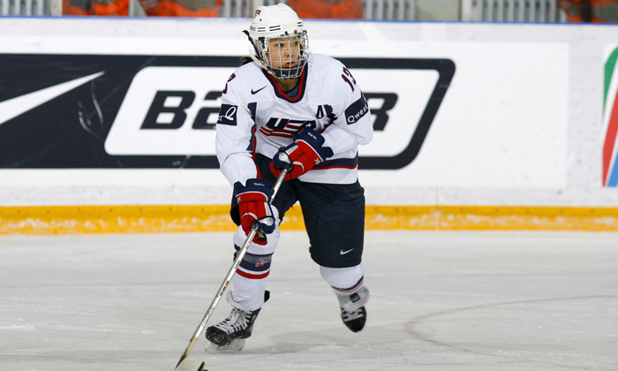
Birthdate: | April 16, 1993
Birthplace: | Montebello, CA
Hometown: | Arcadia, CA
Residence: | Arcadia, CA
Ht: | 5'3"

Mirai Nagasu
Athlete Case #3
Sport: Figure Skating
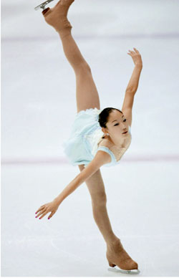
One of the United State’s best figure skaters has been practicing her triple axel all season. Just as she thought it was mastered, she took a severe fall and has sustained a groin strain. The good news is that the Games are still six weeks away. The bad news is that groin injuries can sometimes take a while to heal. She is very discouraged.

Birthdate: | December 12, 1981
Birthplace: | Boise, ID
Hometown: | Boise, ID
Residence: | Park City, UT
Ht: / Wt: | 5'9" / 165 lbs
Olympics: | 2006, 2002

Jeret Peterson
Athlete Case #4
Sport: Freestyle Skiing-Aerials
Practicing a mere 4 weeks from their competition date, one of the United State’s aerial skiers landed incorrectly and suffered an anterior dislocation of his shoulder. With the clock ticking, the medical team must try to salvage the athlete’s Olympic dreams.

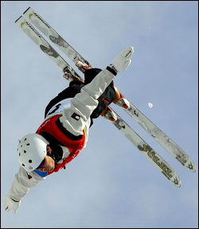
Birthdate: | August 4, 1983
Birthplace: | Novi, MI
Hometown: | Novi, MI
Residence: | Novi, MI
Ht: / Wt: | 5'7" / 173 lbs

Michelle Rzepka
Athlete Case #5
Sport: Bobsled
The brakeman of the women’s Bobsled team sprained her ankle getting into the sled at the top of a practice run. It has been assessed as a Grade 2 sprain. The coach feels that if they can get her back to health three days before competition, then it is worth keeping her in the position and not finding an alternate brakeman. Time is tight; the competition starts in only 2 weeks.

Birthdate: | October 20, 1986
Birthplace: | Yuma, AZ
Hometown: | Midland, MI
Residence: | Salt Lake City, UT
Ht: / Wt: | 6'1" / 180 lbs

Ryan Bedford

Athlete Case #6
Sport: Speed Skating
Training harder than ever to win gold at our home Games, one of the United States best long track speed skaters is suffering from patellar tendonitis (jumper’s knee). He has ignored the symptoms for some time and it is now at the point where he cannot train without severe pain. There is only a month until the Games.

